VALAIS BLACKNOSE BREED SOCIETY
Meeting 26th June 2018
Minutes
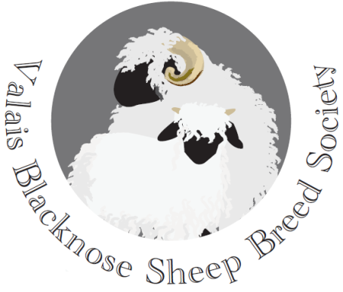
Present:
David Hodge (Chairman) Julian Walters
Tom Hooper (Treasurer) Penny Coulter-Smith
Kate Little (Secretary) Douggie Little
Emma Collison (PR & Marketing)
Chris Slee (Vice Chairman) Sarah Grose

9. Minutes of last cttee meeting on 3rd April 2018
Agreed and signed as a correct record by the Chairman.

10. Apologies
Stuart Billinghurst

11. Matters Arising
The advert for the Society has been sent to, and appeared in, the Farmer’s Guardian.

Membership nos. - it was decided to stay with the allocated VBN no. for each voting member. These will be on the key rings and sent to each member.

It was resolved to take forward the matter of securing a licence for stock registrations on behalf of the Society, to replace the current temporary arrangement with Grassroots agreed in an email from Libby Henson dated 28th Sept. 2015. This would allow the Society to raise funds to promote the breed.

12. Devon County Show debrief
It was felt that the stand had been well presented and attracted much interest. Getting first judging slot in the morning for the Valais class was helpful.
Action: Emma to send photo of champions to the class sponsors.

13. Newsletter
The secretary to put together some text on recent events, the merchandise available to buy and an invitation to attend the social planned for the Dorset Show. PR officer to create the first Society Newsletter.
Action: Emma and Kate to put together the newsletter.

14. Data Protections Regulations 2018 – Privacy Policy
The proposed policy was agreed and will be sent to all members of the Society for them to agree the use of their data.

15. Rule 6 ‘Showing’
Rule 6 presently states: All adult sheep for showing to be shorn in full fleece for the County Shows and sheared for the one day shows. Lambs to be shown in full fleece for all shows.’
The Committee agreed a coda to the rule: the definition of full fleece to be ‘no less than 10cm for both adults and lambs’. The reference to this is in the Swiss rules which say: ‘the fleece length being 10cm, at 5-6 months old’.

16. Budget
There is £546 in the bank and £564 in the Paypal account as of 26.6.18. As things stand the Treasurer is predicting a small loss on the 2018/19 budget at financial year end, but hopefully with improved merchandise sales, this could be rectified.

17. George Hedley Memorial Award
The Committee decided to make no recommendation for this prestigious national award.

18. Any Other Business
(a) It was agreed that a Valais Blacknose breed sale should take place at the Holsworthy Rare Breed sale on 8th September. Classes to be: ram, ram lamb, ewe and ewe lamb.
Action: The PR Officer to follow up with Kivells and to secure sponsorship for a bell. Secretary to order rosettes.

(b) Royal Cornwall Show: Want to secure a specialist class for the breed.
Action: Secretary to write to the Show sheep secretary to confirm how this can be secured.

(c) Website: The PR Officer is to create a Members’ area and a ‘stock for sale’ section. Will also offer the opportunity for rams for hire to be advertised. Need a disclaimer for this part of the site.

Next meeting: 24th July 2018 at Moorlands North Belstone EX20 1QZ at 7.30pm.

Signed: ………………………………………. Date ……………………………….
Chairman

