VALAIS BLACKNOSE BREED SOCIETY
Meeting 7th August 2018
Minutes
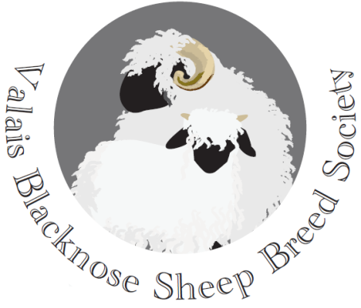
Present:
David Hodge (Chairman) Julian Walters
Tom Hooper (Treasurer) Douggie Little
Kate Little (Secretary)
Emma Collison (PR & Marketing)

19. Minutes of last cttee meeting on 26th June 2018
Agreed and signed as a correct record by the Chairman.

20. Apologies: Chris Slee, Sarah Grose and Penny Coulter-Smith

21. Matters Arising:
- The response from Grassroots re registrations and the need to ensure that all stock registered were of the correct standard for the breed. A future project to explore could be organising stock inspections prior to registration.

- The membership list has been brought up to date and all members will receive their keyring with their membership no.

22. The Holsworthy Show and Sale 8th September 2018
The classes will be:
- Ewe over 1 year old
- Ewe lamb
- Ram over 1 year old
- Ram lamb
- Whether

Classes are only open to members of the breed society. The entry fee will be £2 per animal. All sheep shown must be offered for sale. Additional stock can be put up for sale.

23. Dorset Agricultural Show 1st-2nd September
The arrangements for the BBQ were agreed. To meet at the VBN pens at 6.30pm for drinks and then to the camping area for the social.

24. Website update
The new Members area is being worked on.

25. New Members’ Pack.
At present this is just to be the keyring as other info is on the website.

26. Any other business
The next AGM will take place on Saturday 16th February 2019 at Malvern. Secretary to book the same hotel as last time.

The next meeting will take place on 26th September – venue to be agreed

Signed: ………………………………………. Date ……………………………….
Chairman

