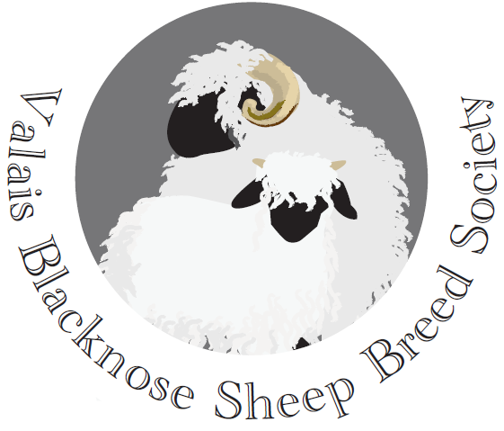
AGENDA

ANNUAL GENERAL MEETING

15th February 2020
6.00pm

at The Mount Pleasant Hotel, Great Malvern

1. Apologies

2. Minutes of last AGM on 16th February 2019– attached

3. Matters arising

4. Chairman’s annual report

5. Treasurer’s annual report

6. Society eartags

7. Registration of pedigree stock and the matter of ‘breeding up’.

8. New website

9. Membership cards

10. Upcoming events:

- VBN Breed Show and Sale at Sedgemoor Market, Somerset – date to be agreed
- Judging and Showing training day in the autumn 2019 – date and venue to be agreed

11. Election of the Chairman, Vice Chairman, Treasurer and Secretary for 2020-2022.

Members of the uncontested election for the Management Committee are:
David Hodge, Chris Slee, Tom Hooper, Kate Little, Emma Collison, Stuart Billinghurst, Douggie Little and Renee V. Snouckaert. Four places unfilled.

12. Any other business

