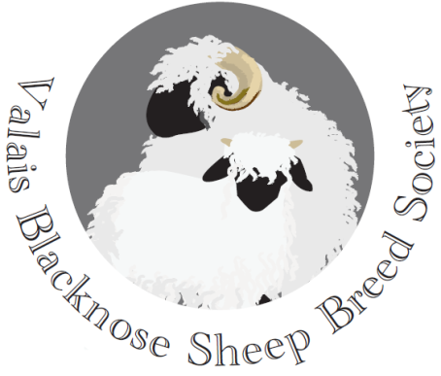

VALAIS BLACKNOSE BREED SOCIETY
Minutes of the Annual General Meeting
Held at The Mount Pleasant Hotel, Great Malvern
Saturday 16th February 2019

Present:
David Hodge (Chairman) Kate Little (Secretary)
Tom Hooper (Treasurer) Emma Collison (PR)

Stuart Billinghurst Stuart Glyde Layla Roshan
Daniel Coombes M. Gregory Diane Rusbridge
Morah Etchels Hayley Harris Helen Smith
Phil Garrod Douggie Little Paul Smith
Andy Giles Amanda Ridings Renee Snoucksert
Kathy Giles Clare Roshan Julian Walters
Polly Glyde

1. Apologies: Sarah and Andrew Grose; Chris Slee

2. Minutes of last AGM on 10th February 2018: Agreed and signed as a correct record by the Chairman.

3. Matters Arising: None

4. Chairman’s Annual Report: The Chairman welcomed everybody to the Society’s second Annual General Meeting and gave a resume of the year’s activities. This began with the Devon County Show in May 2018 where there was a good representation of Valais sheep in all the classes. The breed stand had attracted much attention as had the sheep. The Society sponsored sashes for the Champion ram and ewe and a perpetual bell for the Champion of Champions. It also did so for the Nantwich and the Dorset County Shows. There was an equally good entry at the Dorset show where the Society BBQ took place on the Saturday evening.

The Society held it’s first Show and Sale at Holsworthy Market, Devon in September at the invitation of Kivells, as part of the Rare Breeds Sale. The Vice Chairman Chris Slee judged the show element and prices were buoyant in the sale, with prices of between £2 – 2’600 for ewes.

The Chairman then moved on to upcoming events. This year the Kent Show will be having Valais classes for the first time, using a judge from the The Society’s judges panel and sashes and a bell will provided for those competitors who were Society members (show your membership card). The 2019 Show and Sale will be at Sedgemoor Market, Bridgewater in Somerset on Thursday 5th September. There will be a medical check on all entries. This year. On Sunday 15th September there will be a judging and showing training day, with refreshments, at Lower Halstock Farm near Okehampton, Devon (more details nearer the time).

The Chairman thanked the members of the Committee for their hard work during the year and welcomed new members of the Society, which he hoped will continue to grow. Finally he hoped that it would be possible at some time the future to visit Switzerland to talk to the Swiss judges about the breed to gain a better understanding of their competition marking system.

5. Treasurer’s Report: The Breed Society is set up a formal company and it files returns for an annual budgeting year of July – June. The 2017/18 return has been filed. This shows a deficit for the in-year budget, due to legacy issues, including outstanding website costs, a fine for late filing of earlier accounts to HMRC and the upfront costs of the Society’s merchandise. It is anticipated that the 2018/19 budget will be in surplus.

Grassroots which registers all pedigree Valais sheep UK wide, retains 100% of the registration fee at present. Unfortunately the cost of taking over the registration database is beyond the Society’s resources and there is an issue of data protection – the flock book cannot be simply handed over without the consent of all those whose data is kept on the system. The consequence is that the Society’s finances are constrained.

It was resolved to approve the accounts for the last financial year.

6. The Motion that Rule 6(b) in the Rules and Regulations be amended to read:

Rule 6 - Shows
(b) All sheep to be shown in full fleece or a minimum of 10cm fleece length for all County agricultural shows

Was agreed.

7. 2019 Membership cards were handed out to all paid up members of the Society. Those not attending the AGM will be sent their cards shortly.

8. Upcoming events: Were referred to in the Chairman’s report.

9. AOB:

(i) Entry fees for the Sale and Show – At the Holsworthy Sale the auctioneers retained the whole sale commission and this needs to be considered for the next event at Sedgemoor. Also there may need to be a higher entry fee payable to the Society.

(ii) Chesire Show – it was suggested that this show could have Society sponsored sashes and bell. Secretary to write to the Show Secretary. Also Society leaflets should be available for handing out.

(iii) Grassroots registrations- It was suggested that there could be a parallel registration system with the Society. Committee to consider.

(iv) Membership – The Treasurer confirmed there were 20 paid up members of the Society [since the AGM this has increased to 26 – with more enquiring every week]. There is currently an issue with old rotating Paypal payments coming in throughout the year. The Society is trying to align all payments at the beginning of the year.

(v) Why do many breeders not join the Society? – When selling VBN’s, Society breeders should produce Society application forms with the pedigree paperwork. VBNs are not easy sheep to raise and the Society can provide advice and guidance.

(vi) Society’s Judges’ Panel – A number of existing longwool judges who were already on another breed panel, had been approached with a view to being on the VBN Society’s panel. There are now 9 judges on the panel. A judging training day is planned – see above. It was recommended by those present that the Chairman and Vice Chairman go to Switzerland to learn the Swiss judging practices.

(vii) No. of rams being registered – In 2018 37% of VBNs being registered were rams which is far too many. Only the best marked and well conformed males should be kept entire. All others should be turned into wethers. There was discussion about creating a market for wethers. It was also suggested that shows should be encouraged to include a wether class (not eligible for the champion or inter-breed classes). [Since the AGM Nantwich Show has agreed to have a wether class].

The Chairman thanked everyone for their contributions to the debate and closed the meeting at 7pm.

Signed: ……………………………………. Date: …………………………..
Chairman

