VALAIS BLACKNOSE BREED SOCIETY
Meeting of 26th September 2018
at Alturnum, Cornwall
Minutes
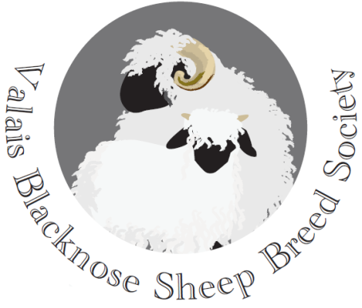
Present:
David Hodge (Chairman) Julian Walters
Chris Slee (Vice Chairman) Penny Coulter-Smith
Tom Hooper (Treasurer) Sarah Grose
Kate Little (Secretary) Douggie Little
Emma Collison (PR & Marketing)

27. Apologies: Penny Coulter-Smith and Julian Walters

28. Minutes of last cttee meeting on 7th August 2018
Agreed and signed as a correct record by the Chairman.

29. Matters Arising:

- Dorset Agricultural Show – It was agreed that the show had gone very well for the Society and the sheep had proved popular with visitors. The Society will have the annual ‘social’ there again next year. Emma was thanked for doing the BBQ this year.

- 2019 AGM – It was resolved to re-book the Mount Pleasant Hotel at Great Malvern for this year’s AGM on 16th February 2019.
Secretary to book the conference room and ask if the winter menu can be changed to reflect the farming activity of the members.

30. Specialist classes at other shows – It was agreed to pursue a specialist Valais class at the Royal Cornwall Show. Hopefully there would be enough entries to justify this.
Secretary to write and confirm this would be the case

31. Holsworthy Sale and Show – debrief
It was felt that the show and sale had been a good first effort and Emma was thanked for making the arrangements. A lot had been learned about how the event could be improved in the future. It was resolved (proposed by DH and seconded by DL) that the next sale and show would take place at Sedgemoor Market (on the M5 in Somerset) about the same time of year, on a Saturday – the auctioneers have been approached and are interested. It was also resolved (proposed by DL and seconded by SG) that Julian Walters and Chris Slee would be responsible for running the 2019 event. A independent inspector would be secured to undertake a condition check on incoming stock. There was discussion about limiting nos. per entrant in each class and about securing a Swiss judge to undertake the grading of stock. This will be discussed further at the next meeting.

32. Financial position – The current position is that the Society has £1’233 in reserves.

33. Website update – The website needs updating re copyright declarations, more recent photos of shows, show results and committee membership.

34. Proposed article in the Country Smallholders Magazine – It was agreed that it would be better to aim for this in March/April along with a VBN Breed Society advert in both this magazine and the Farmer’s Guardian.

35. Next news letter – winter 2018/19 – Aim to produce this for early January 2019. Items to include a Chairman’s letter, show results, details of the upcoming AGM, and foreshadow the next breed sale date.

36. Any other business:

- Secretary to write to the Devon County Show Sheep Secretary to find out why the VBN Breed Society was not invited to the breed society meeting held recently at the showground.

Date of next meeting: 11th December 2018, at 7.30pm, venue to be confirmed.

Signed: ………………………………….. Date: …………………………….
Chairman

